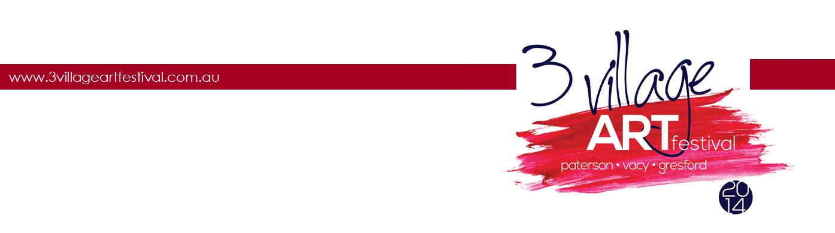

Market stall registration

Form

The 3 Village Art Festival will be held across 4 locations on the 24th, 25th May. Market stalls will be held in the towns of Paterson, Vacy and Gresford. Please register your interest to hold a stall during the Saturday 24th and/or Sunday 25th of the festival.
- Each stall holder is required to provide their own public liability and a copy of this will be required to complete your registration.
- Registrations will close on the 10th May
Registration Form:
Products Sold
Name of Stall Holder
Postal Address
Contact Number
Email Address

Which days will you participate (circle) |  | Saturday $15 | Sunday $15

Total money owed
Type of payment Cheque / Credit / Visa

Note: You will be notified of your stall location once registration has closed.

Please fill out the above form and email or post it to:
3 Village Art Festival
21 King Street
Paterson, NSW, 2421 Or
stephigribble@gmail.com

Cheques may be made payable to
3 Village Art Festival Inc
Or please request a credit/visa card payment form
www.3villageartfestival.com.au 21 King St Paterson NSW 2421

